Assignment No. 1

Create the following tables with the given structures and insert sample data as specified: -

1 🡪 CREATE DATABASE SunbeamAssignment;

2🡪 use sunbeamassignment;

1. SALESPEOPLE TABLE:

3🡪 CREATE TABLE SALESPEOPLE (Snum int(4),Sname varchar(10),City varchar(10), Comm float(3,2));

4🡪insert into salespeople values(1001,'Peel','London',.12);

5🡪 select \* from salespeople;

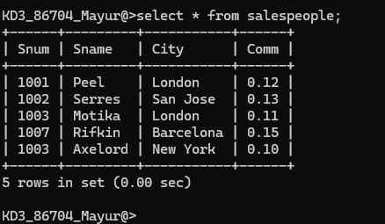

1. CUSTOMERS TABLE

1🡪 CREATE TABLE CUSTOMERS(Cnum int(4),Cname varchar(10),City varchar(10),Rating int(4),Snum int(4));

2🡪 insert into customers values(2004,'Grass','Berlin',300,1002);

3🡪 insert into customers values(2008,'Cisneros','San Jose',300, 1007);

4🡪 insert into customers values(2007,'Perira','Rome',100,1004);

5🡪 insert into customers values(2006,'Celmens','London',100,1001);

6🡪 insert into customers values(2002,'Giovanni','Rome',200,1003);

7🡪 select \* from customers;

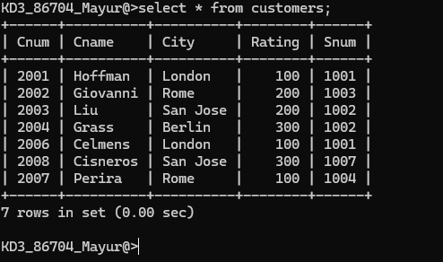

1. Order table :

insert into orders values(3002,767.19,'1990-10-03',2007,1004),

-> (3005,5160.45,'1990-10-03',2003,1002),

-> (3006,1098.16,'1990-10-03',2008,1007),

-> (3009,1713.23,'1990-10-04',2002,1003),

-> (3007,75.75,'1990-10-04',2004,1002),

-> (3008,4723.00,'1990-10-05',2006,1001),

-> (3010,1309.95,'1990-10-06',2004,1002),

-> (3011,9891.88,'1990-10-06',2006,1001);

